**Segmentation: Traditional & Deep learning Approaches💡**

[[VK](https://medium.com/@VK_Venkatkumar?source=post_page-----edd50a3308b3--------------------------------)](https://medium.com/@VK_Venkatkumar?source=post_page-----edd50a3308b3--------------------------------)

[VK](https://medium.com/@VK_Venkatkumar?source=post_page-----edd50a3308b3--------------------------------)

·

[Follow](https://medium.com/m/signin?actionUrl=https%3A%2F%2Fmedium.com%2F_%2Fsubscribe%2Fuser%2F60f6508bffaf&operation=register&redirect=https%3A%2F%2Fmedium.com%2F%40VK_Venkatkumar%2Fsegmentation-traditional-deep-learning-approaches-edd50a3308b3&user=VK&userId=60f6508bffaf&source=post_page-60f6508bffaf----edd50a3308b3---------------------post_header-----------)

7 min read

·

5 days ago

48

Computer vision is an interdisciplinary scientific field that deals with how computers can gain high-level understanding from digital images or videos. From the perspective of engineering,it seeks to understand and automate tasks that the human visual system can do.

In the following article, I discuss segmentation based on deep learning and traditional approaches.

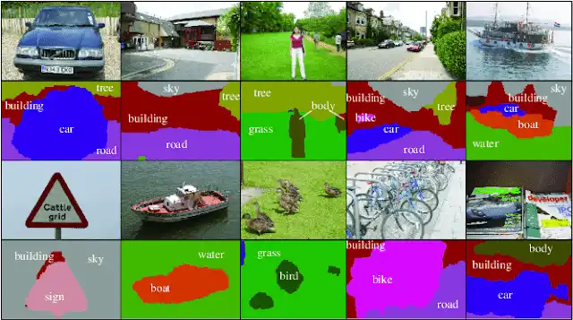

Credit: Online

Initially let me briefly explain segmentation, detection, and classification. After that, we’ll talk about segmentation.

**What difference in Image classification, Object detection, Semantic and Instance Segmentation?**

**In simply way describe all things:**

1. what object is present? — **Image classification**

2. classification+where it is present? — **object detection**

3. object detection+pixel level classification — **semantic segmentation**

4. semantic segmentation+instance differentiate the classes (same classes represent the different color in pixel level) — **instance segmentation**

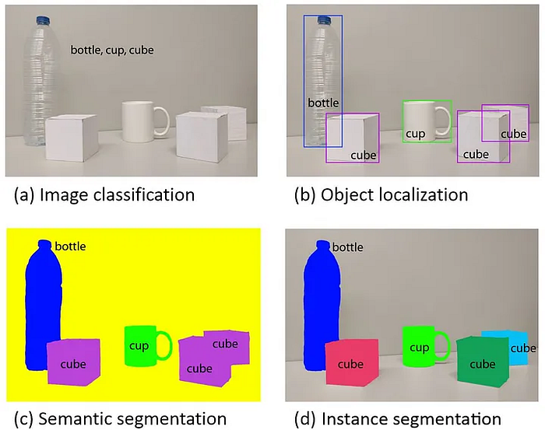

Credit: Online

**WHAT & WHY ?**

* Segmentation in computer vision involves partitioning an image into distinct regions, enabling targeted analysis of specific areas. This process is crucial for tasks like object recognition, where it simplifies complex visual data and enhances algorithmic efficiency.
* It is essential for applications such as image analysis, robotics, and medical imaging, enabling more effective and meaningful interpretation of visual data.

**Traditional Approach of Segmentation:**

* Threshold Method
* Region Based Method
* Edge Based Method
* Watershed Based Method
* Clustering Method

**Threshold Method:**

Threshold-based image segmentation is a technique where pixels in an image are classified into different regions based on their intensity values relative to a predefined threshold.

**Pixels with intensities above the threshold are assigned to one region, while those below the threshold belong to another.** The threshold value T can work as a constant in low-noise images. In some cases, it is possible to use dynamic thresholds. Threshold divides a grayscale image into two segments based on their relationship to T, producing a binary image.

This method is simple and effective for separating objects from the background when there is a clear contrast in intensity, making it a commonly used approach in image processing and computer vision applications.

import cv2  
import numpy as np  
from matplotlib import pyplot as plt  
  
# Read the image  
image = cv2.imread('car.jpg', cv2.IMREAD\_GRAYSCALE)  
  
# Apply thresholding  
\_, binary\_image = cv2.threshold(image, 128, 255, cv2.THRESH\_BINARY)

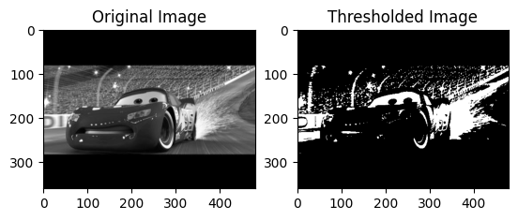

output

**Region Based Method:**

Region-based image segmentation is a technique that divides an image into distinct regions based on certain criteria, such as pixel similarities or color homogeneity. It aims to group pixels with similar properties into coherent regions, making it easier to analyze and understand the content of an image. This approach helps identify meaningful structures and objects within the image by focusing on the local similarities of pixel values within different regions.

*Region-based segmentation involves dividing an image into regions with similar characteristics. Each region is a group of pixels, which the algorithm locates via a seed point. Once the algorithm finds the seed points, it can grow regions by adding more pixels or shrinking and merging them with other points.*

import cv2  
import numpy as np  
  
# Read the image  
image = cv2.imread('car.jpg')  
  
# Convert the image to grayscale  
gray = cv2.cvtColor(image, cv2.COLOR\_BGR2GRAY)  
  
# Apply thresholding to create a binary image  
ret, thresh = cv2.threshold(gray, 0, 255, cv2.THRESH\_BINARY\_INV + cv2.THRESH\_OTSU)  
  
# Perform morphological operations to clean up the image  
kernel = np.ones((3, 3), np.uint8)  
opening = cv2.morphologyEx(thresh, cv2.MORPH\_OPEN, kernel, iterations=2)  
  
# Identify sure background area using dilation  
sure\_bg = cv2.dilate(opening, kernel, iterations=3)  
  
# Identify sure foreground area using distance transform  
dist\_transform = cv2.distanceTransform(opening, cv2.DIST\_L2, 5)  
ret, sure\_fg = cv2.threshold(dist\_transform, 0.7 \* dist\_transform.max(), 255, 0)  
  
# Identify unknown region  
sure\_fg = np.uint8(sure\_fg)  
unknown = cv2.subtract(sure\_bg, sure\_fg)  
  
# Marker labeling for watershed algorithm  
ret, markers = cv2.connectedComponents(sure\_fg)  
markers = markers + 1  
markers[unknown == 255] = 0  
  
cv2.watershed(image, markers)  
  
image[markers == -1] = [0, 0, 255] # Mark watershed boundaries in red  
  
cv2.imwrite("output.png",image)

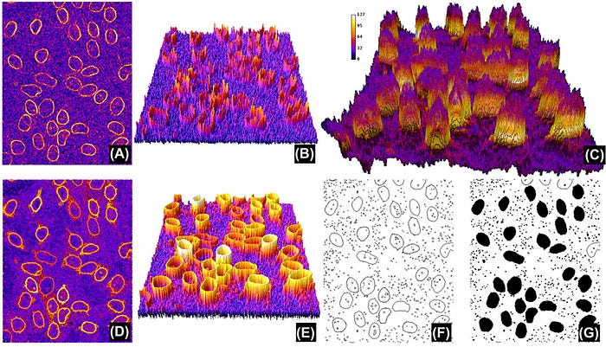

credit: Online

**Edge based Method**

Edge-based segmentation is a popular image processing technique that identifies the edges of various objects in a given image. It helps locate features of associated objects in the image using the information from the edges. Edge detection helps strip images of redundant information, reducing their size and facilitating analysis.

Edge-based segmentation algorithms identify edges based on contrast, texture, color, and saturation variations. They can accurately represent the borders of objects in an image using edge chains comprising the individual edges.

***For further information, check out this article; it’s quite helpful.***

**[Edge Detection Using Kornia (Sobel, Canny, Deep learning based DexiNed) — Part II](https://medium.com/@VK_Venkatkumar/edge-detection-using-kornia-sobel-canny-deep-learning-based-dexined-part-ii-e2c31672058f?source=post_page-----edd50a3308b3--------------------------------" \t "_blank)**

[Hi guys, i think already you know edge detection if you don’t know go and check my previous edge detection post](https://medium.com/@VK_Venkatkumar/edge-detection-using-kornia-sobel-canny-deep-learning-based-dexined-part-ii-e2c31672058f?source=post_page-----edd50a3308b3--------------------------------" \t "_blank)

[medium.com](https://medium.com/@VK_Venkatkumar/edge-detection-using-kornia-sobel-canny-deep-learning-based-dexined-part-ii-e2c31672058f?source=post_page-----edd50a3308b3--------------------------------" \t "_blank)

**[Edge Detection (Gradient(Sobel, prewitt, Canny) vs Deep learning (Holistically - Nested) Approach)…](https://medium.com/@VK_Venkatkumar/edge-detection-gradient-sobel-prewitt-canny-vs-deep-learning-holistically-nested-approach-49bff706ae57?source=post_page-----edd50a3308b3--------------------------------" \t "_blank)**

[Computer vision is an interdisciplinary scientific field that deals with how computers can gain high-level…](https://medium.com/@VK_Venkatkumar/edge-detection-gradient-sobel-prewitt-canny-vs-deep-learning-holistically-nested-approach-49bff706ae57?source=post_page-----edd50a3308b3--------------------------------" \t "_blank)

[medium.com](https://medium.com/@VK_Venkatkumar/edge-detection-gradient-sobel-prewitt-canny-vs-deep-learning-holistically-nested-approach-49bff706ae57?source=post_page-----edd50a3308b3--------------------------------" \t "_blank)

# Read the input image  
image\_path = 'car.jpg'  
original\_image = cv2.imread(image\_path, cv2.IMREAD\_GRAYSCALE)  
  
# Apply Gaussian blur to the image to reduce noise and improve edge detection  
blurred\_image = cv2.GaussianBlur(original\_image, (5, 5), 0)  
  
# Apply Canny edge detector  
edges = cv2.Canny(blurred\_image, 50, 150) )

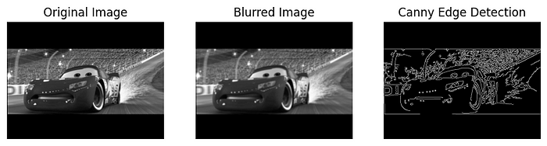

Output

**Clustering Based Method**

Clustering algorithms are unsupervised classification algorithms that help identify hidden information in images. They augment human vision by isolating clusters, shadings, and structures. The algorithm divides images into clusters of pixels with similar characteristics, separating data elements and grouping similar elements into clusters.

# Read the image  
image = cv2.imread('car.jpg')  
  
# Reshape the image to a 2D array of pixels  
pixels = image.reshape((-1, 3))  
  
# Convert pixel values to float  
pixels = np.float32(pixels)  
  
# Define criteria and apply kmeans()  
criteria = (cv2.TERM\_CRITERIA\_EPS + cv2.TERM\_CRITERIA\_MAX\_ITER, 100, 0.2)  
k = 3 # You can adjust the number of clusters as needed  
\_, labels, centers = cv2.kmeans(pixels, k, None, criteria, 10, cv2.KMEANS\_RANDOM\_CENTERS)  
  
# Convert back to 8-bit values  
centers = np.uint8(centers)  
  
# Map the labels to their corresponding center values  
segmented\_image = centers[labels.flatten()]  
  
# Reshape back to the original image shape  
segmented\_image = segmented\_image.reshape(image.shape)  
  
# Display the original and segmented images  
cv2.imwrite('Segmented Image.png', segmented\_image)

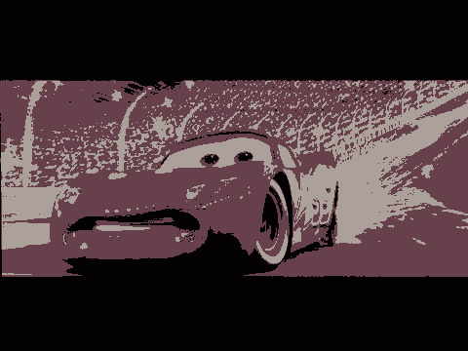

output

**Watersheds Based Method**

Watersheds are transformations in a grayscale image. Watershed segmentation algorithms treat images like topographic maps, with pixel brightness determining elevation (height). This technique detects lines forming ridges and basins, marking the areas between the watershed lines. It divides images into multiple regions based on pixel height, grouping pixels with the same gray value.

The watershed technique has several important use cases, including medical image processing. For example, it can help identify differences between lighter and darker regions in an MRI scan, potentially assisting with diagnosis.

**Additionally, region-based and watershed approaches are nearly identical.**

My Coding Exploration:

**[Traditional\_and\_Deeplearning\_Based\_Segmentation/Traditional\_based\_segmentation.ipynb at main ·…](https://github.com/VK-Ant/Traditional_and_Deeplearning_Based_Segmentation/blob/main/Traditional_based_segmentation.ipynb?source=post_page-----edd50a3308b3--------------------------------" \t "_blank)**

[Contribute to VK-Ant/Traditional\_and\_Deeplearning\_Based\_Segmentation development by creating an account on GitHub.](https://github.com/VK-Ant/Traditional_and_Deeplearning_Based_Segmentation/blob/main/Traditional_based_segmentation.ipynb?source=post_page-----edd50a3308b3--------------------------------" \t "_blank)

[github.com](https://github.com/VK-Ant/Traditional_and_Deeplearning_Based_Segmentation/blob/main/Traditional_based_segmentation.ipynb?source=post_page-----edd50a3308b3--------------------------------" \t "_blank)

**Deep learning Approach:**

**Deep learning-based segmentation**utilizes neural networks, such as convolutional neural networks (CNNs), to automatically identify and delineate objects or regions of interest within images. These models learn complex hierarchical features, enabling precise segmentation tasks in diverse fields like medical imaging, computer vision, and remote sensing. The training process involves optimizing the network’s parameters to accurately map input data to corresponding segmentation masks.

I’ve already released segmentation based on deep learning, which is really beneficial to you all.

**[Semantic Segmentation using U-Net (Aerial Data)](https://medium.com/@VK_Venkatkumar/semantic-segmentation-using-u-net-aerial-data-40f9548ff361?source=post_page-----edd50a3308b3--------------------------------" \t "_blank)**

[Computer vision is an interdisciplinary scientific field that deals with how computers can gain high-level…](https://medium.com/@VK_Venkatkumar/semantic-segmentation-using-u-net-aerial-data-40f9548ff361?source=post_page-----edd50a3308b3--------------------------------" \t "_blank)

[medium.com](https://medium.com/@VK_Venkatkumar/semantic-segmentation-using-u-net-aerial-data-40f9548ff361?source=post_page-----edd50a3308b3--------------------------------" \t "_blank)

***According to my observations, segmentation requires relatively little computational power and can identify objects extremely accurately, segmenting them based on their regions. That’s the finest.***

***However, the article included traditional and deep learning techniques. Deep learning is a good method, all the same. However, we must all be familiar with the conventional approach. We have to employ the conventional procedure because it depends on the problem. Deep learning requires more memory, hence in this instance, the conventional approach is used. Furthermore, traditional segmentation is known to all computer vision engineers. Because there are so many new ready-made frameworks available these days, not everyone is familiar with the basic principles of technology.***